STWP Process Template
(PC’s Note: This is just a general guideline. Each client is different. These tasks are in a general order, but in many cases will be moved around, added onto, deleted, etc. dependent on the client & their needs)

Client Strategy Meeting **Not all clients need this**
1. PC – Make sure you’ve received client’s Pre Kickoff meeting form
2. PC – Schedule meeting, if needed
3. PC – Check all hosting account sites to make sure they work
4. PC – Check current website access to make sure it works (if applicable)
5. PC – Add Google Analytics login information to site access doc in the Google tab
6. Jane to determine pages for site
7. Jane to do keyword research and send to client

Kickoff Meeting
1. PC – Coordinate times and schedule meeting with client
2. PC – Kickoff Meeting
- Make sure to invite Juliette via Google Cal to the meeting OR email her for availability!
3. PC – Create meeting minutes and send to client/timeline/next steps
4. PC – If we are writing marketing messages, free report, blogs or about page, see ‘Extra Section’ below. A writer needs to be assigned immediately!
- Be sure to add writer to LGED project!

Site Theme
1. PC – Help client determine theme (could be via email or a phone meeting, or could have been decided during kickoff)
2. PC – Purchase theme (use paypal account or CC if needed)
- Contact Meagan for Paypal password if you don't already have it.
3. PC – Send theme to developer to install (download and attach to LGED task)
4. PC – Enter cost of theme as expense in LGED (if its an Elegant Themes product, we already have a membership so we get it for free, but still charge the client)

Set up Development Environment
1. PC – Tell developer where to put it (cwdevel.com, practicebuildingbook.com, etc) & what to name it
2. DEV – Install wordpress in Dev area, install attached theme & add login information into Site Access doc
3. PC – Check to make sure login and password works for backend of dev site after DEV adds to site access

Site Layout
1. DEV – Install standard plugins (Mailpoet, Yoast SEO, Contact Form 7, Akisment, W3 Total Cache, Backup Buddy, Google Analytics for Wordpress plugin)
- MAKE SURE YOAST IS TURNED OFF, make sure site is NOT being indexed!!!!
2. DEV – Create pages in nav bar
- PCs - Tell DEV what the top nav bar items are.
- For example:
  - Home
  - Specialties
  - About
  - Blog
  - Contact
- In footer, put the following pages:
  - Terms of Service
  - Privacy Policy
3. DEV – Create right side bar – content on the left, right side bar
- PCs - sometimes clients don't want this, so just determine what they want
4. PC – If client is writing their own marketing messages, remind them to keep writing to get their product done ASAP & go live date.
5. PC – If we are writing the marketing messages, free report, or about me – make sure the writer aligns with the go live schedule.
- Make sure they are writing the pages they need to write - keep in touch with the writers.
6. PC – Header and Footer items – Collect header and footer items, existing logo, address, phone, forms, credibility icons
7. DEV – Remove the name of the theme in the header and put the logo & client name on the left side, and contact info (location and phone number) on right
- PCs - If client has a logo on their previous site, you can pull the logo from their old site.
8. DEV – Install contact information in header and footer
- ***HEY PC's - Let developer know where the address & phone number are going to be located in the header and footer.
9. PC – Show client the site, NOT for approval, just to let them see the progress
10. PC – Font – We will use the theme default font, unless client asks for others
11. PC – Generate Terms of Service/Privacy Policy pages
- Visit http://www.freeprivacypolicy.com/login.htm and login with the following information:
- Username: admin@page1pros.org
- Password 848624
- See how to here:
- Privacy Policy: http://stwproject.cwdevel.com/privacy-policy-process/
- Terms of Service: http://stwproject.cwdevel.com/terms-of-service-process/
12. DEV – Add Privacy Policy page and Terms of Service page to footer and build pages
- PC's - Tell developer location of where the PP & TOS will go in the footer
- PC's - Send the code to the developer as an .txt or .rtf document attachment. IF you use Microsoft word, or similar docs, it will mess up the code. If you have questions, ask another PC. See screenshot: http://screencast.com/t/BKAvMtGTo4
13. DEV – Upload existing content from current site to dev site
- PC's - Check with client about which pages can be copied.
14. DEV – Upload final marketing messages and make sure to have a consistent format for header and footer (this task is meant to be repeated for one specialty)
- PC's - Get final content from client or from one of our writers. Attach final copy to the task.
15. DEV – Upload home page content
- PC's - This task only pertains to the developer if there is NEW home page copy.
16. PC – If client is doing a free report, get their elastic email account info
- Send the client this:
  - "Please sign-up for an Elastic E-Mail account, so that we can integrate this account in for automatic e-mails using MailPoet. You can go here to sign up for an account:http://elasticemail.com/.
  - After you sign up, my recommendation is to go to 'Get Credits', and buy $20.00 worth of credits (this will get you 20,000 e-mails); if you could please send us the login information for your account after you've signed up, that would be great."
17. DEV – Upload free report 3D cover, upload free report PDF and integrate with Mailpoet
- PC's - IF the client is doing a free report, assign this task.
18. DEV – Upload about page content
- PC's - If client wants new content written, ask them for it. If not, have developer copy from old site.
19. DEV – Upload blog posts into correct categories
20. DEV – Set up blog categories for each specialty
- PC's - Categories are based on specialty pages. Tell developer's what they are called.
21. DEV – Set up corresponding photos on homepage
- PC's - This depends on whether they are slider photos or a static photo banner.
22. DEV – Set up corresponding photos on specialty pages
23. DEV – Pull in corresponding blog posts in right side nav for corresponding specialties for each specialty page
- PC's - Each specialty page should have a right hand sidebar that includes post from correlating category. Have developer label it depending on the specialty page - for example 'Couples Posts' or 'Adults Posts'
24. DEV – Create 3 screenshots with 3 color backgrounds & use the following hex codes
25. DEV – Integrate elastic email into mailpoet (if client has free report)
- PC's - include elastic email login info here
26. PC – Colors – Show client 3 screenshots of the homepage with 3 background colors
- PCs - Client must provide colors they prefer via other websites. PC must provide these colors in a hex code
27. PC – Blog posts – encourage client to write one blog post for each specialty before we go live, or if we are writing the blogs for the client, find out status
28. PC - Photo Selection Process – Client to choose from Istockphoto.com or Dreamstime.com
- PC's - Client to choose photos. PC purchases photos and logs expense for client in LGED. Contact Meagan for credit card or paypal information.
- It is preferable to choose photos AFTER color is CHOSEN by CLIENT.

Hosting
1. PC – Get hosting choice from client – send them hosting email (from hosting email template in P2)

Prepare for Launch
1. DEV – Point DNS to client’s preferred email
- PC's - To ensure launch goes smoothly, get the email address from the client where they want to receive their emails for their new website (we recommend it point to the free email services - like gmail, yahoo, etc).
2. PC – Get google analytics login and password from client
3. PC – If client has existing site, check for Google Analytics & retrieve UA number for DEV
- You do this by:
  - Go to current site.
  - Go to 'Page Source' on the site (this is found in different places depending on the browser. On Chrome, for example, you can find it by clicking on 'View > Developer > View Source')
  - Press 'Control f' or 'Command F' (on macs), and in the search bar in the top right hand corner of the page, type in UA-
  - Copy the UA- code (everything between the two ' marks) - see screenshot: http://screencast.com/t/Wq15222CzFxL
  - Send the UA code to the developer (see next task to do so)
4. PC – If client doesn’t have Google Analytics – Create GA Account
- If you searched their old site, and you didn't find a UA code, you will need to set up a Google Analytics account for the client.
- See Pre Kick off form for Gmail login info.
- Sign up for Google Analytics using this email info: http://www.google.com/analytics/ (see this link for help: https://support.google.com/analytics/answer/1009694?hl=en)
- Once you've signed them up, retrieve UA number from account and send to DEV. See next task to send to developer.
5. DEV – Install Google Analytics
- PC's - Must provide UA number. For questions, ask another PC.
6. PC – Obtain possible email subscriber lists & format lists to integrate (in Excel)
7. DEV – Integrate email list(s) to Mailpoet (if client had existing subscriber list)
8. PC – If client using new URL, have them purchase it (there’s a video showing them how in STWP members area), and get the registrar info so we can use for new site
9. PC – QA Testing/Bug fixing Pre-Launch (This is a QA Checklist)
  - PC - Did you login to the registrar (for example GoDaddy) with username and password to make sure it works?
  - Checking the Website - check every page on the website, check every link on the website, navigate from homepage to every page, make sure it looks okay, make sure any links on those pages go to the correct place (no 404 error)
  - ***Question - should we add the 404 plugin as a standard plugin?
  - Make sure the images look good throughout the site - make sure they all come up
  - ***Try all these in multiple browsers*** (do main check in chrome, then check a few pages in safari and firefox)
  - On the specialty pages, is the sidebar correct - is there an optional free report, testimonials (if they have them), and are the blog posts on the bottom RELEVANT to that page
  - Is name and address in the footer
  - Does the contact form work - test the contact form - does it go to the correct email - check with them
  - Do their social media icons go to their social media page
  - Make sure terms of service and privacy policy pages are there
10. PC – Get 301 redirect plan in place – set up links in Excel and Upload to developer
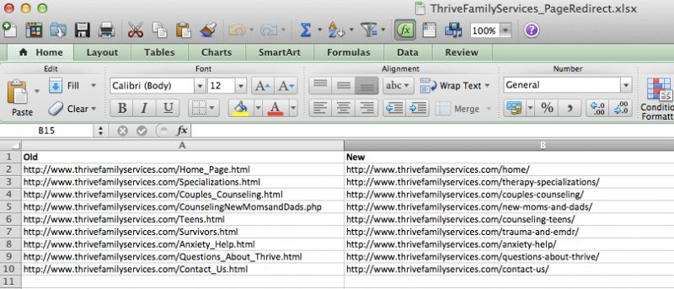
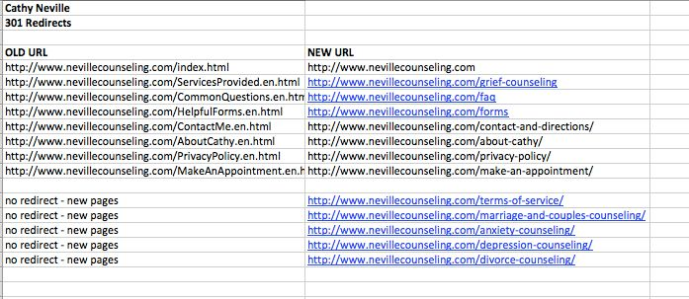

Go Live
1. DEV – Backup the site in the development environment
2. DEV – Change any email addresses you may have used for testing (for example – Mailpoet)
3. DEV – Enable site to be indexed – change reading settings in Yoast SEO plugin
4. DEV – Create any email addresses needed (i.e. clientname@sitename.com)& forward email addresses to client’s gmail/yahoo/etc
- PC - Give any addresses for the site to the developer. Have them forward it to their main email address (which should be through a free email service provider - ie gmail, yahoo, hotmail)
5. DEV – Set up FTP Access in the new site once new site is up permanently
6. DARYL – If client’s hosting with us, add client site to Sucuri for malware monitoring – ASSIGN TO DARYL ONLY
7. DARYL – If client hosting with us, add site to ManageWP to monitor WP plugin and various status – ASSIGN TO DARYL ONLY
8. DEV – Change Admin username to client name. Also, change email address in both the contact form and mailpoet to client’s email address
9. DEV – Change the Contact Form’s Messaging (message in details of task)
Contact form message should say: “Thank you for contacting me. I will reply to you as soon as possible”
10. DEV- Change Mailpoet – change the ‘from’ field from Admin to Client Name
11. DEV – Change Mailpoet’s Messaging (message in details of task)
Optin Box on site: “Thank you for requesting my free report. Check your inbox now to confirm your subscription.” Optin
Email Confirmation:
Email Subject: Confirm Your Report Download
Email Text:
“Hello!
Thanks for requesting my free report. In order to receive your report and to activate your subscription to the list, please click the link below:
Click here to confirm your subscription. (link)”
12. PC – Test the contact form to make sure the contact form is going to the client email

On Site SEO
1. Jessie to optimize each specialty page & homepage

Post Launch
1. PC – Give client login access (found in site access doc), WP101 tutorial info & ‘How To’ Mailpoet doc
- http://www.wp101.com/wp-login.php
- username: page1pros
password: page1pros
- Here is the mailpoet doc: http://stwproject.cwdevel.com/mailpoet-training-doc-to-send-to-clients/
2. PC – If we’re hosting, let Sarah/Becky know that billing should begin
3. DEV – Delete development site after new site is officially set up
4. DEV – After the site is live, please do the following 301 redirect with attached link redirect
- PC - attach 301 redirect link document in this task

Extra
1. PC – Free Reports – Make sure to get title of Free Report for designer (only if we are doing the design work)
- We need the title of the free report in order for the designer to start work.
2. PC – Free Reports – Get report cover from client or assign to our designer if we’re doing inhouse
- Get flat version AND 3D image of free report cover
3. PC – Free Reports – Format free report/combine PDF
4. DEV – Free Reports – Upload 3D image of free report to page & integrate PDF into mailpoet
- PCs - You must attach the PDF of the free report and the 3D image to this task.
5. PC – If client wants us to do the logo, then we contact Fiverr
- We need to know what kind of logos the client likes. Ask client what style they like, or other logos they may like.
6. PC – Forms – If client wants Interactive Forms/Survey Forms/Assessment Interactive option with Visual Form Builder Pro, Gravity Forms, must get content from client
7. PC – Testimonials – If client is adding testimonials to sidebars, get them and pass on to developer with instructions about what goes where
8. DEV – Upload testimonials to right side nav
- PCs - If client has testimonials, send them to the developer and tell them what pages to be added to.

Additional Add Ons
1. DEV – If there will be audio, upload audio
- PCs - get this from client and tell developer where to put it. Send to developer as an attachment.
2. DEV – If video, upload to site
- PCs - if client has video, tell developer where to put it and send as attachment.
3. DEV – If client wants to use a payment system (paypal, 1shoppingcart, etc) install it
- PCs - We need the payment system login information from the client (for example - paypal account information) so the developer can install it.
4. DEV – If client wants social media streams (FB or Twitter) add to appropriate locations
- PCs - Send social media information to developer, if client wants this. For example, their specific facebook account.
5. PC – Make sure to show client how to integrate SM icons
- Check the P2.
6. DEV – If client wants appointment scheduling system, upload to site
- PCs - specify specific code that needs to be integrated into the wordpress site from appointment scheduler service.
7. PC – Have client get Elastic Email account – elasticemail.com - $20 for 20,000 emails
8. DEV – If client wants vCita, then install it and configure it with client preferred messages
- PCs - Find out the messaging and profile picture they want for vCita.

